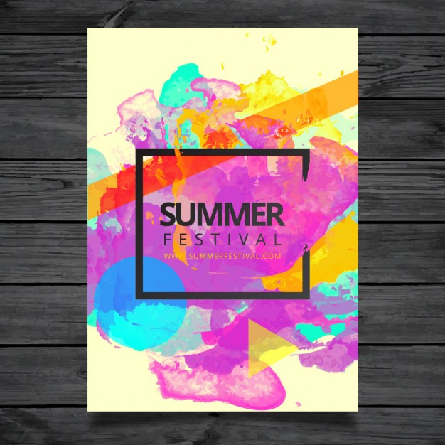

**Proudly Presented By**

BHAGWAN PARSHURAM INSTITUTE OF TECHNOLOGY

ViBe 2018